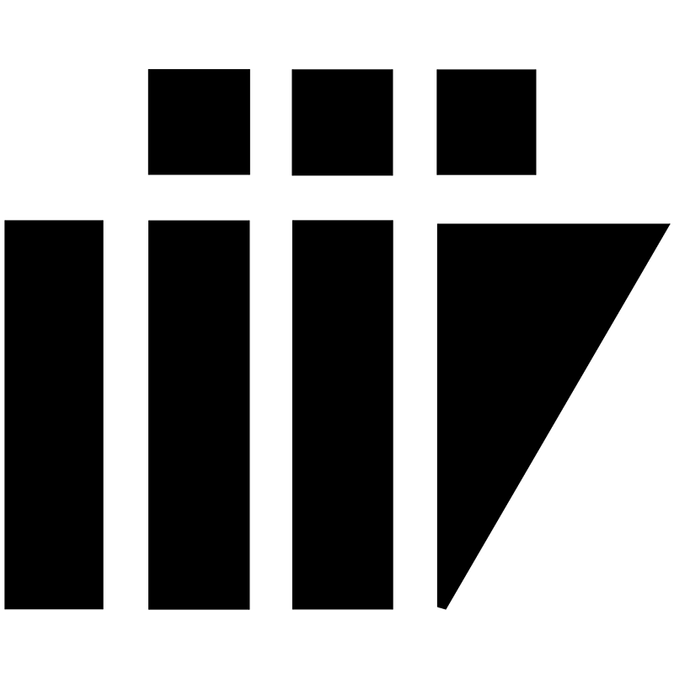

TRAVEL DIARIES

SDLC ACCEPTED MODEL

VERSION 1.0
AUTHORED BY: INDU, DURGAVIJAYALAKSMI

REVIEWD BY :

PROJECT NAME - TRAVEL DIARIES

INSTRUCTOR NAME - ASIM BANERJEE

GROUP NO - 05

GROUP MEMBERS : G RAJU KOUSHIK

NILESH CHATURVEDI

SHREYA SINGH

B.INDU

B.DILEEP KRISHNA

AKHIL PEDAPALI

DURGA VIJAYALAKSHMI

RAVI KUMAR PATEL

JITENDRA SINGH

TABLE OF CONTENTS

S.NO TOPIC PAGE NO.

1. INTRODUCTION 04
2. DIAGRAM 04
3. ADVANTAGES 04
4. REASON 05

SDLC MODEL

Accepted Model:Evolutionary Model
INTRODUCTION:
Evolutionary software models are Iterative.They are characterized in manner that enables the software engineers to develop increasingly more complete version of a software.That is, initially a rapid version of the product is being developed and then the product is being developed to more accurate version with the help of reviewers who review the product after each release and submit improvements.Specification ,Development and validation are interleaved rather than separate in Evolutionary Software process model.

This model is also known as SUCCESSIVE VERSIONS model.Each successive version of a product is a working version.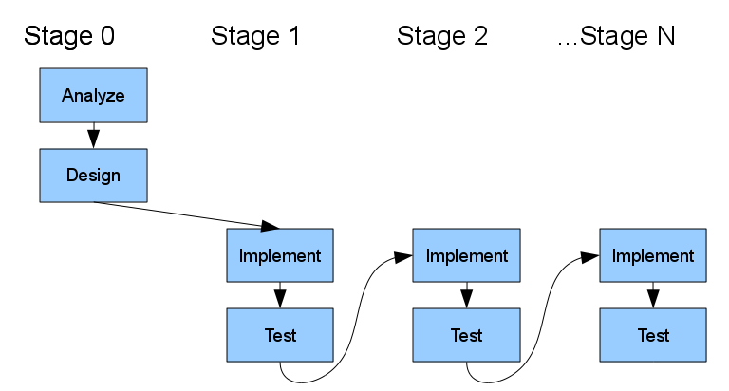

ADVANTAGES:
- Early visibility of the prototype gives users an idea of what the final system looks like.
- Encourages active participation among users and producer.
- Enables higher output from a user.

- Increases system development speed.

- Assist to identify any problem with efficacy of earlier design,requirements and coding activities.
- Helps to refine potential risks associated with the delivery of the system being developed.
- Various aspects can be tested and quicker feedback can be get from the user.
- Helps to deliver the quality easily.

REASON :
As our project “TRAVEL DIARIES “ is a social networking platform in which it targets a large number of users to use in a efficient and flexible way,so we choose this model. The models helps to work on the core or basic requirements first . we can deliver the product to the user and get feedback from them.By surveying the feedback the producer can try to reach the requirements of the user and develop a new model consisting of previous requirements and the new requirements got from the survey of the user.In this model we can even go back to any previous phase and modify whenever u want.This model is less time consuming as compared with other models like waterfall model,Iterative waterfall model etc..In this model the best feature is we can update and add more requirements for the product.Initially there is a rapid version of the product and it is being developed by to more accurate version with help of reviewers who review the product after each release and submit improvements.

